CN ASSIGNMENT 3
Q1. Connect one PC with another PC
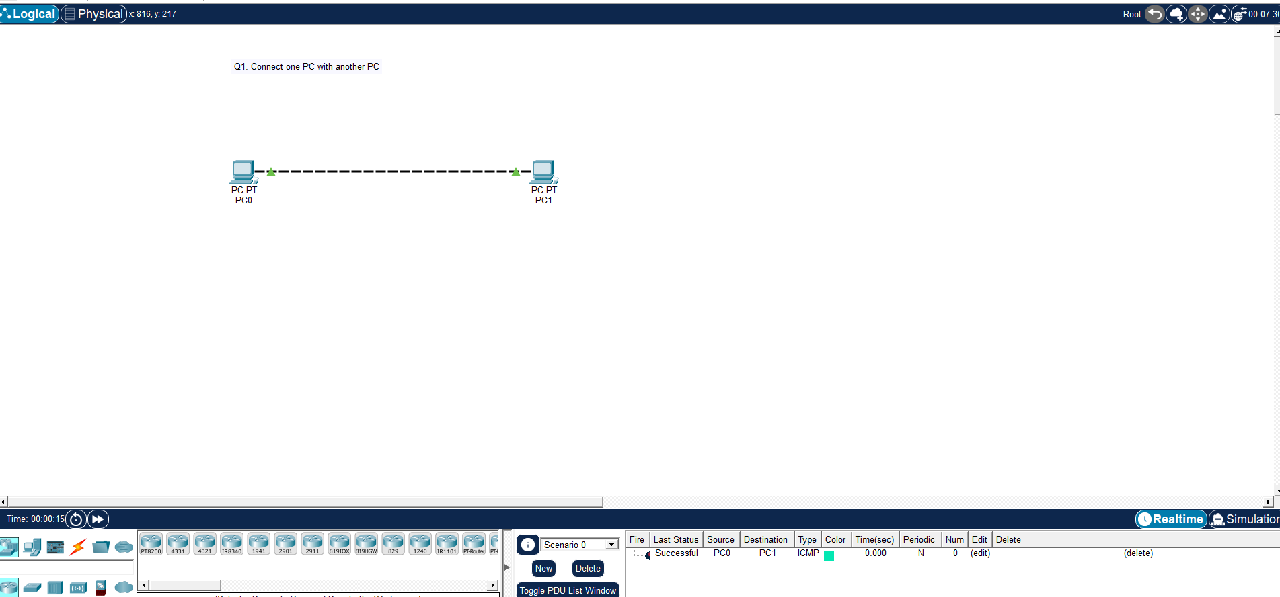

Q2. Connect a PC with Router Ethernet port

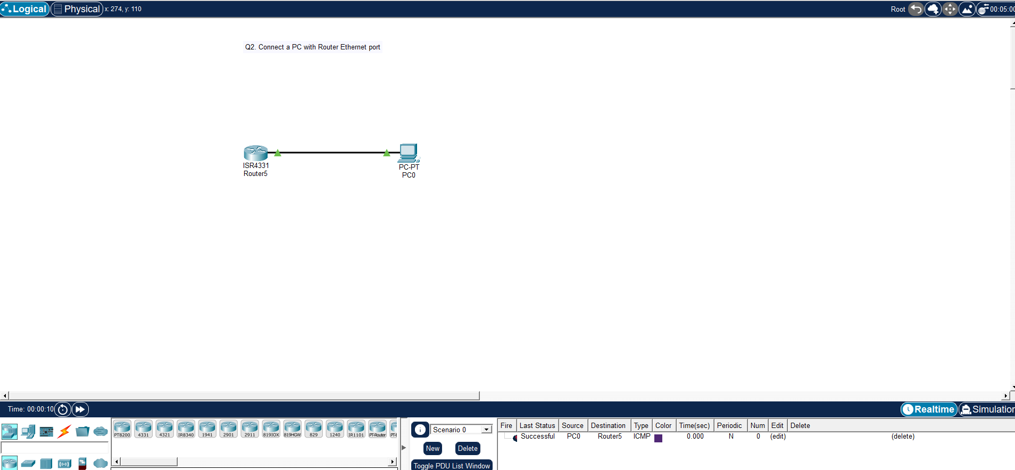

Commands for Router

enable
configure terminal
interface gig 0/0/0
ip address 10.128.20.254 255.255.0.0
no shutdown
exit

Q3. Create a network of 2 PCs

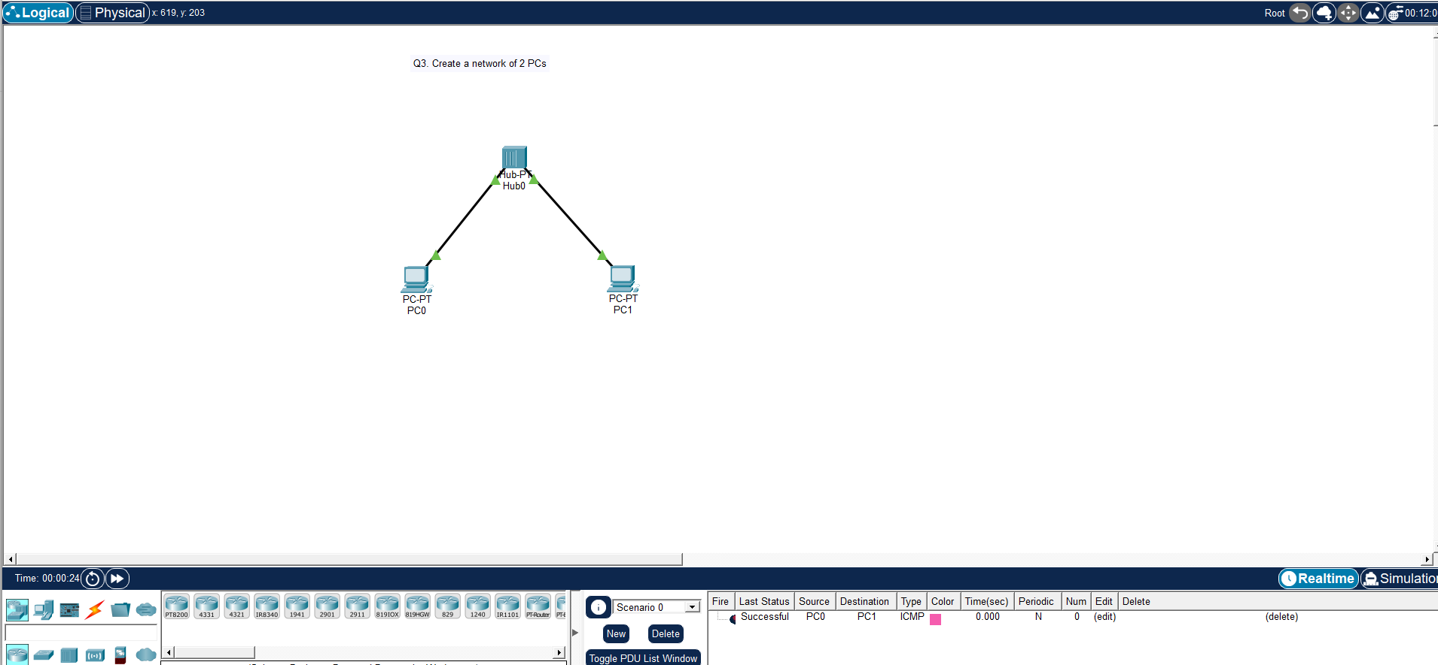

Q4. Connect 2 PCs with a Switch
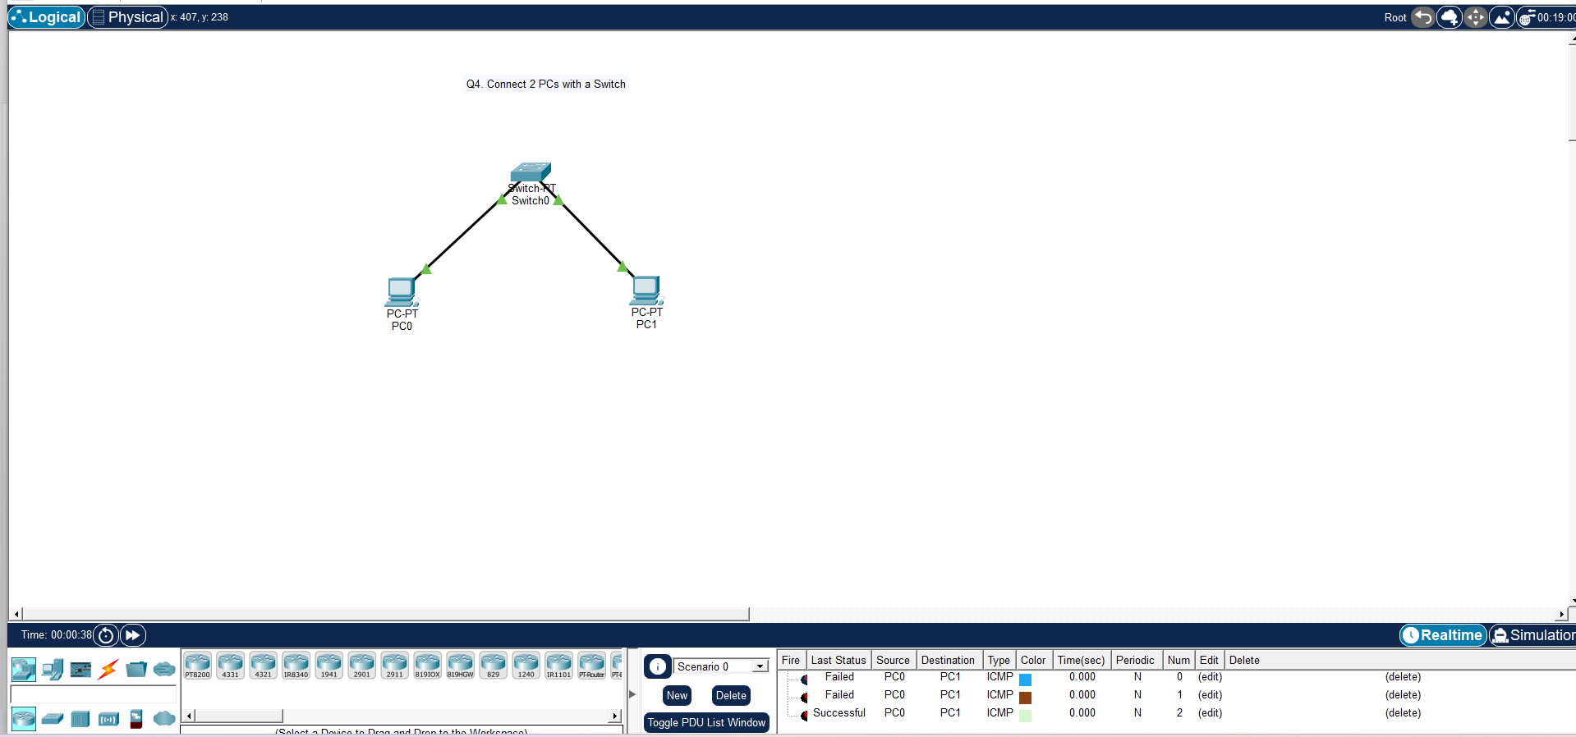

Q5. Create BUS topologies
A)
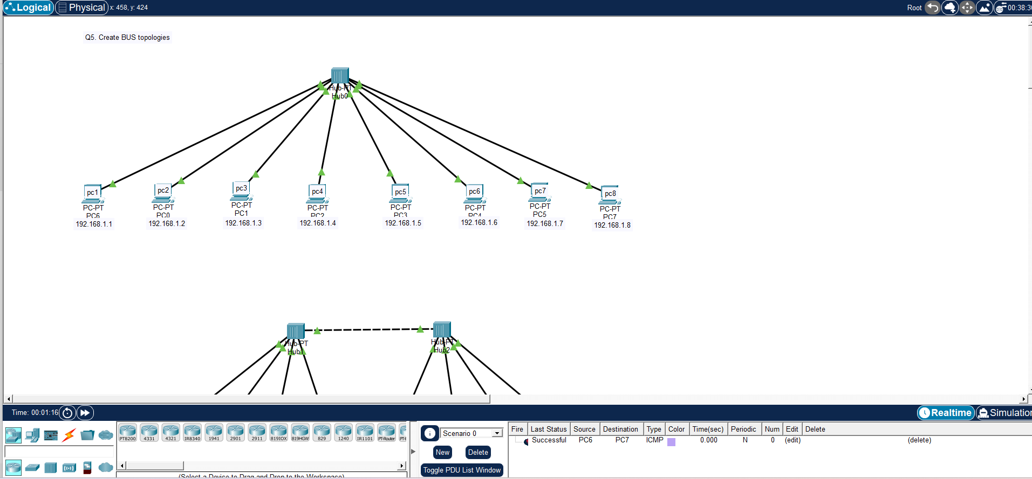

B)
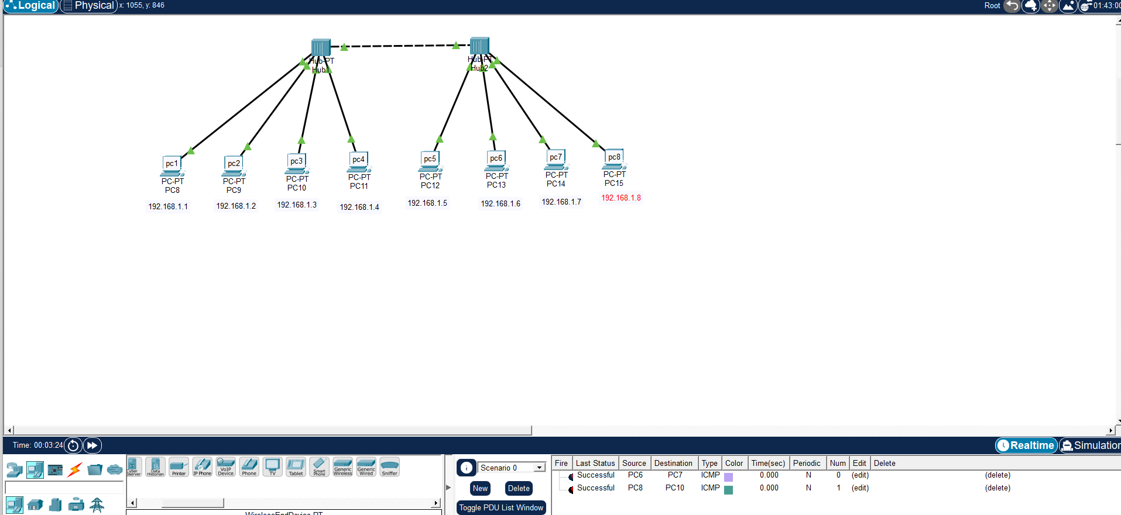

Q6. Create the following Ring Topology.
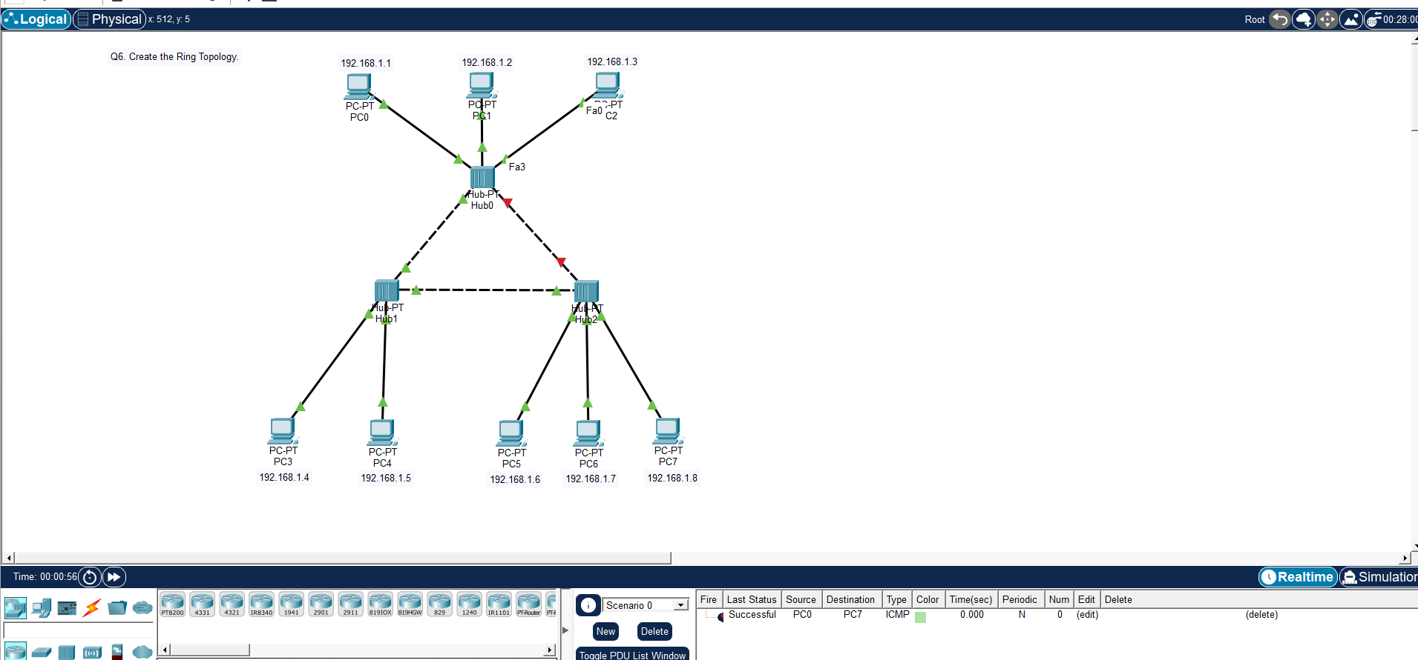

Q7. Create the following Ring Topology.

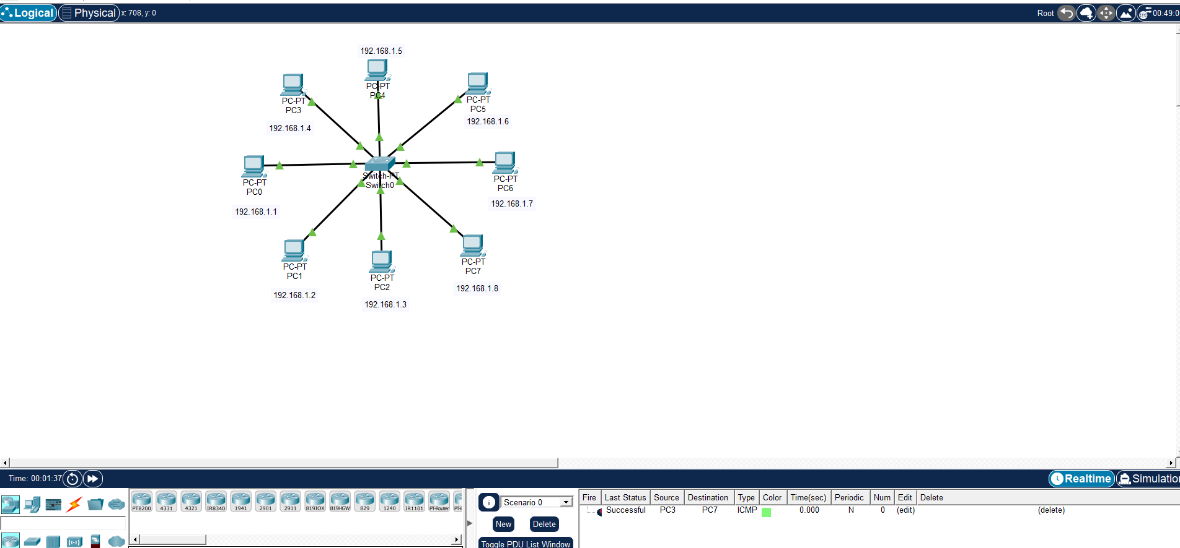

Q8. Create the following Tree Topology.

